**CROW’S FEET ERD USING CARDINALITIES AND CONNECTIONS**

Business Rules

• A department employs many employees, but each employee is employed by only one department.

• Some employees, known as “rovers,” are not assigned to any department.

• A division operates many departments, but each department is operated by only one division.

• An employee may be assigned many projects, and a project may have many employees assigned to it.

• A project must have at least one employee assigned to it.

• One of the employees manages each department, and each department is managed by only one employee.

• One of the employees runs each division, and each division is run by only one employee.

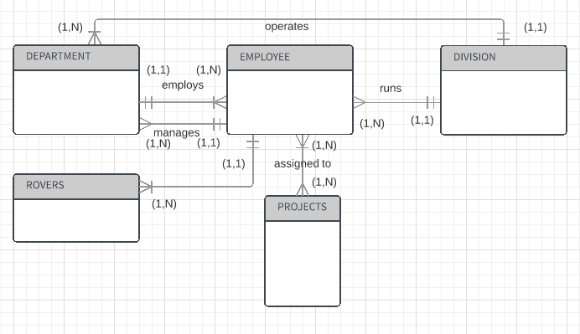

**CROW’S FEET USING SPECIALIZATION HIERARCHY**

Business Rules

Granite Sales Company keeps information on employees and the departments in which they work. For each department, the department name, internal mail-box number, and office phone extension are kept. A department can have many assigned employees, and each employee is assigned to only one department. Employees can be salaried, hourly, or work on contract. All employees are assigned an employee number, which is kept along with the employee’s name and address. For hourly employees, hourly wages and target weekly work hours are stored; for example, the company may target 40 hours/week for some employees, 32 for others, and 20 for others. Some salaried employees are salespeople who can earn a commission in addition to their base salary. For all salaried employees, the yearly salary amount is recorded in the system. For salespeople, their commission percentage on sales and commission percentage on profit are stored in the system. For example, John is a salesperson with a base salary of $50,000 per year plus a 2 percent commission on the sales price for all sales he makes, plus another 5 percent of the profit on each of those sales. For contract employees, the beginning date and end date of their contracts are stored along with the billing rate for their hours.

